**Open Source Graphics & Animation Tools**



**MID-SEM EVALUATION**

**MARCH 2020**

**ON CINDERELLA**

**Submitted to**

**Dr. Durgansh Sharma**

**Professor, Cybernetics SCS, UPES**

**Submitted By**

Name: Reet Dubey

SAP ID: 500070967

Roll No: 76

B. Tech CSE (OSOS) Department of Cybernetics

COMPUTER SCIENCE & ENGINEERING

# Table of Contents

PHASE 1: GIMP...................................................................................................................................3

TOPIC: Cinderella...............................................................................................................................3

ABSTRACT :.........................................................................................................................................3

PROCEDURE .......................................................................................................................................3

EFFECT OF DIFFERENT CHANNELS......................................................................................................7

FINAL OUTCOME :..............................................................................................................................11

# ABSTRACT :

Number of Layers Used: 5

Font used in text: Serif Italic

Kerning in text: 1.0

Leading in text: 3.0

Spacing in text: 1.0

Text Size: 135 px

Text : White

Text Opacity: 100%

# PROCEDURE :

1. Take a 4079*4828 Canvas with white background.
2. Go to Layer << New Layer option, add new transparent layer.

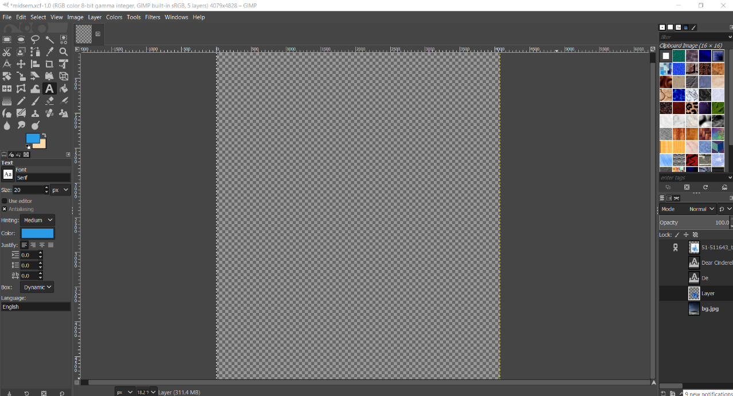

1. Select a background and open it in gimp .

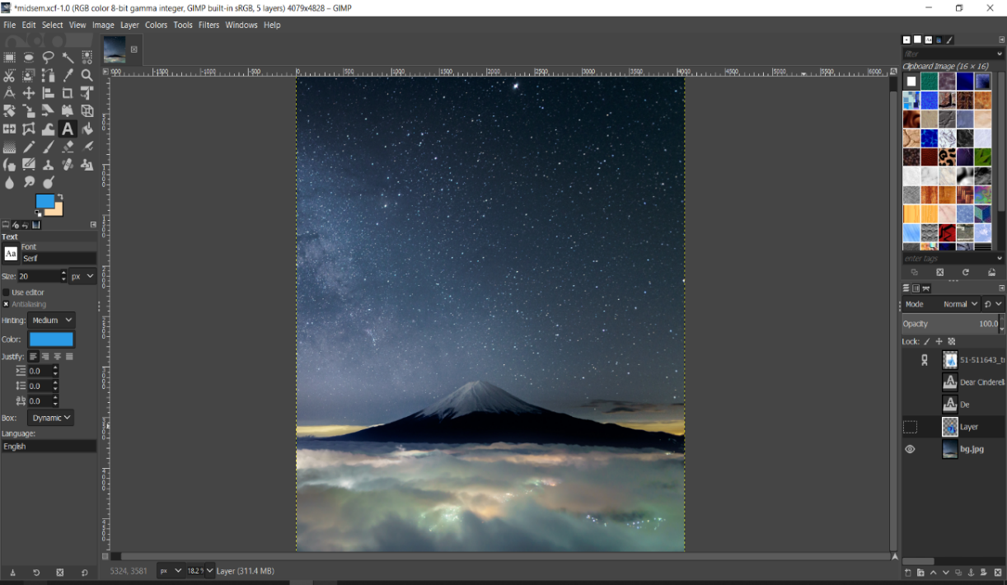

1. Save the image you want to trace and open in gimp using open as layer.

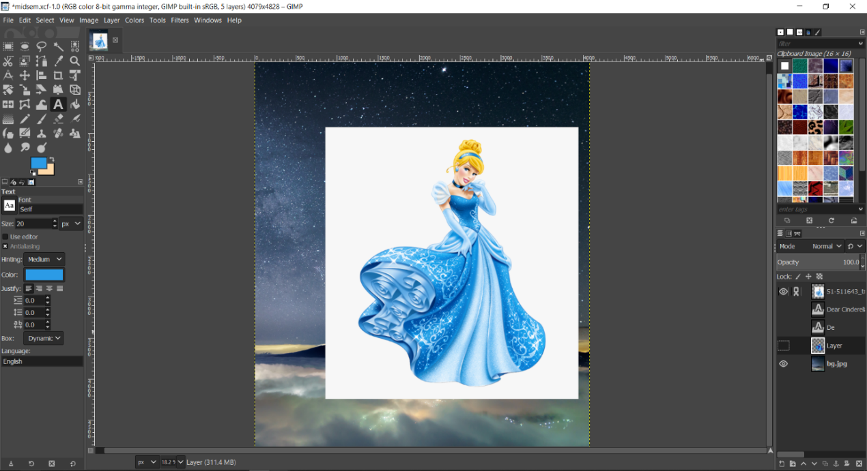

1. Now using the path tool trace out portion by portion.
2. Select a suitable color from the color selection dialog.
3. Create a new layer to trace the Cinderella image.
4. After the trace is complete go to layer then right click and use fill path to fill it with foreground or background colour.
5. For making up the borders and highlighting the porting use fill stroke tool.

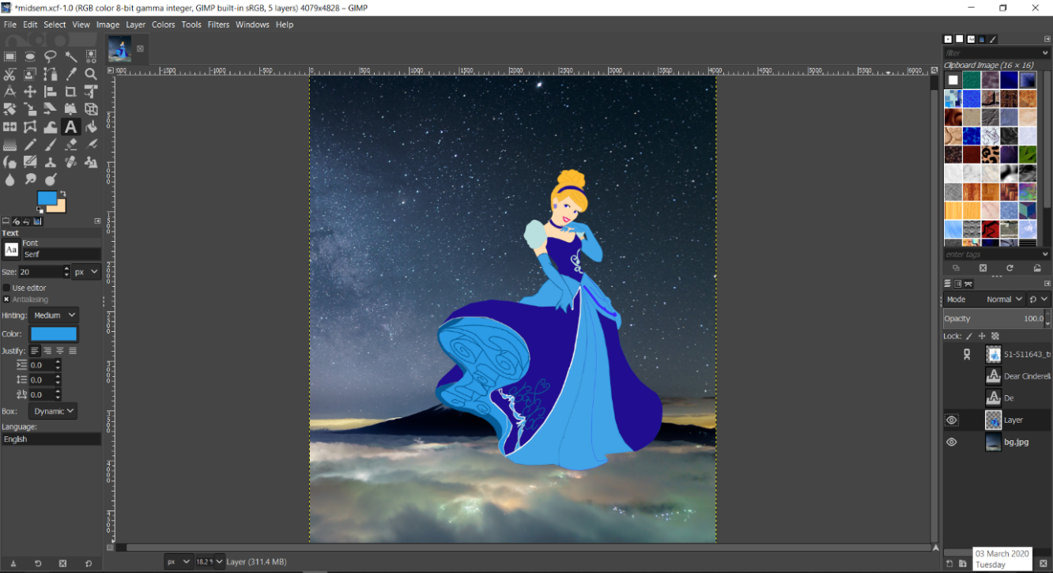

10.After tracing the Cinderella’s Character, Use Text tool to create and edit text layers.

11. Write a text by using following specification –

**Font : Serif Italic**

**Reason** - I have used this font style as there is no doubt that serif type faces are easy to read. Serif italics have the same thick and thin strokes, even if they are extended more; they have the same x height as normal serif type; and they slope in the direction of normal handwriting.

**Text color** **: White**

**Reason** - White color is basically used here to highlight the text in a smart way. The other thing is users can read the content without getting the eye ache.

**Text Size** **: 135 px**

**Reason** – The text size is used here as 135 px for the better visibility.

**Opacity**  **: 100%**

**Reason** -  to make the contents of the layer are opaque

**Kerning : 1.0**

Kerning here is 1.0 to achieve a visually pleasing result.

**Spacing : 1.0**

The better the space between the words , the better its readability becomes. But should not be too much.

**Leading : 3.0**

**Reason** – Leading used here is 3.0 as Increasing the leading allows the text to breathe and makes it appear instantly more attractive. For readers it has practical advantages too—increasing leading makes text easier to read

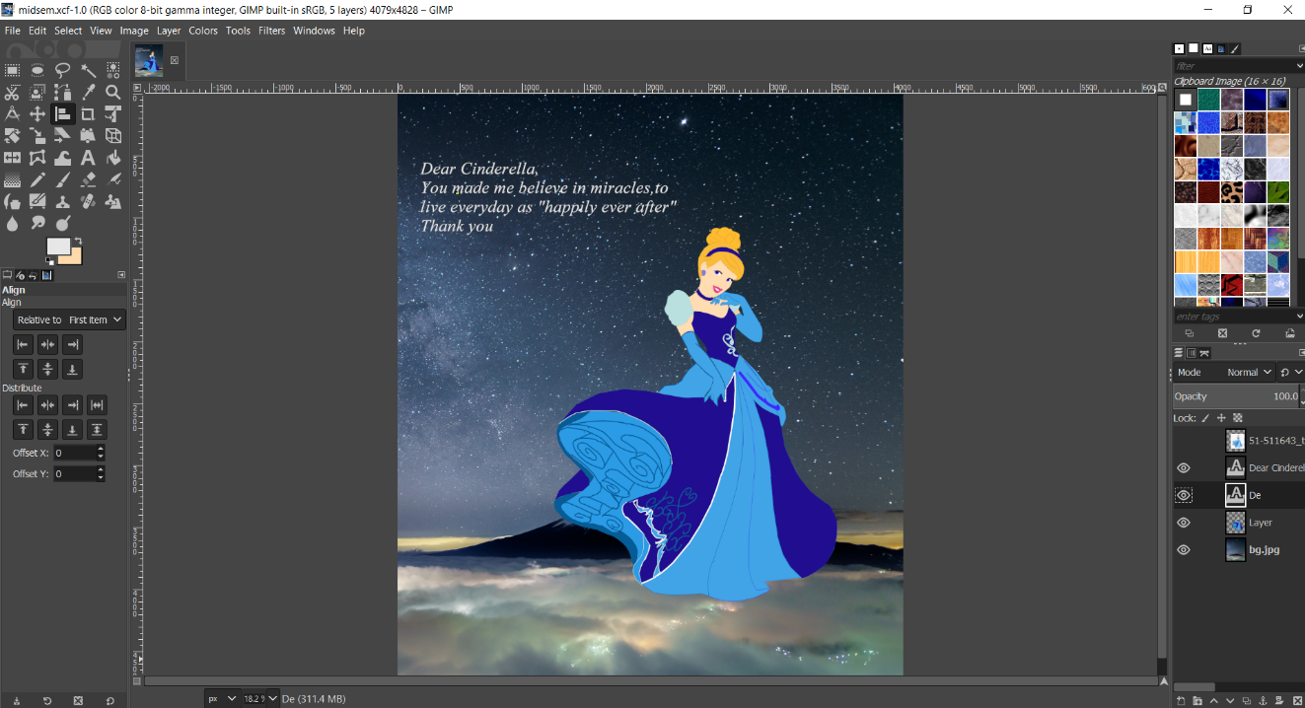

# EFFECT OF CHANNELS

**Effect of Red :**

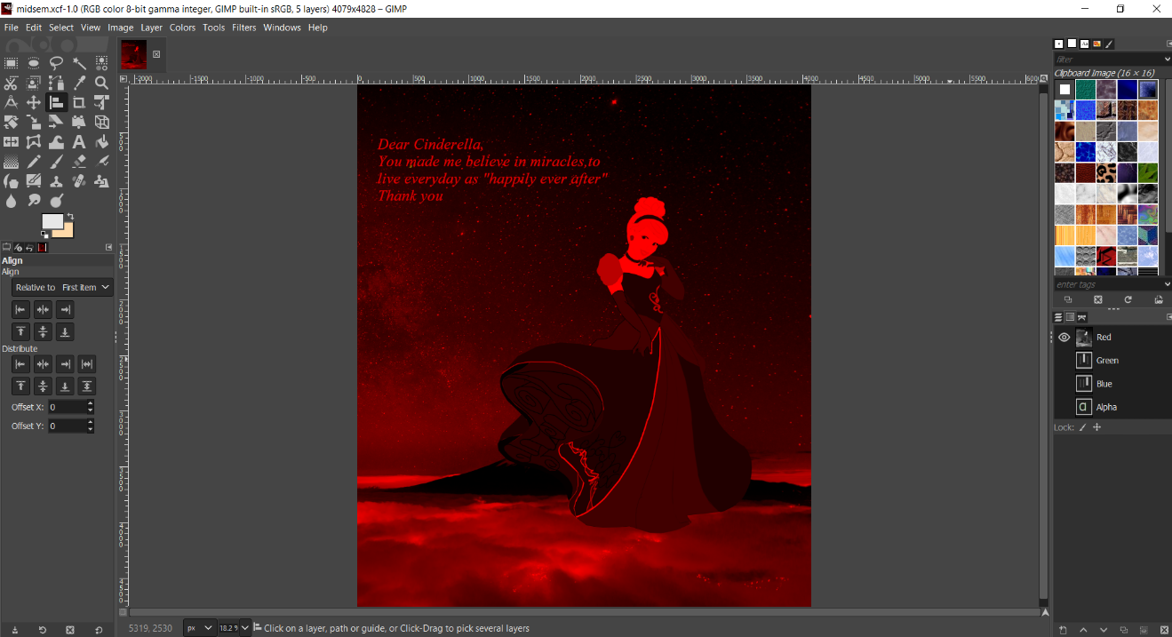

**Effect of Green :**

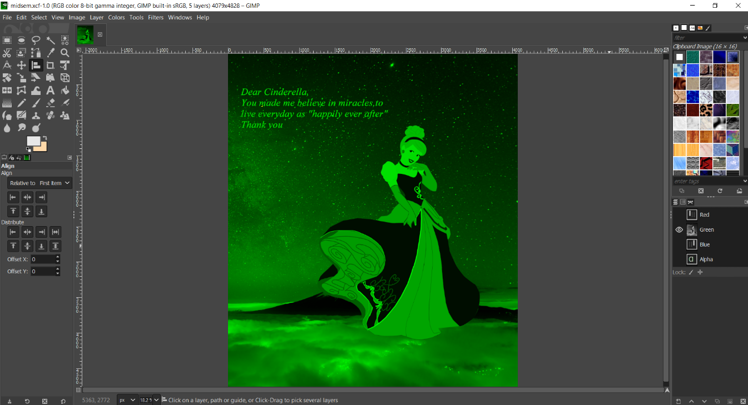

**Effect of Blue :**

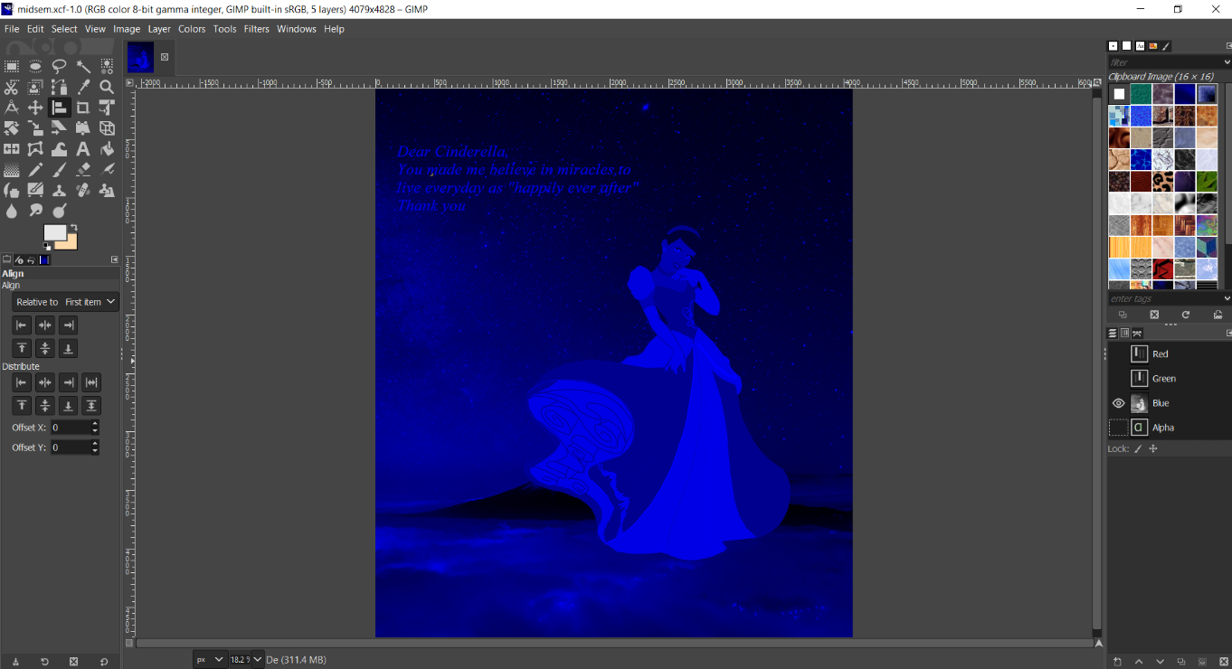

**Effect of Red-Green :**

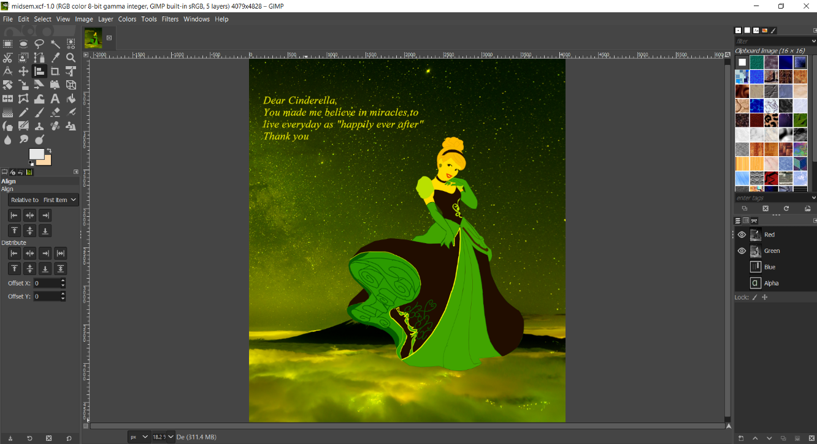

**Effect of Green-Blue**

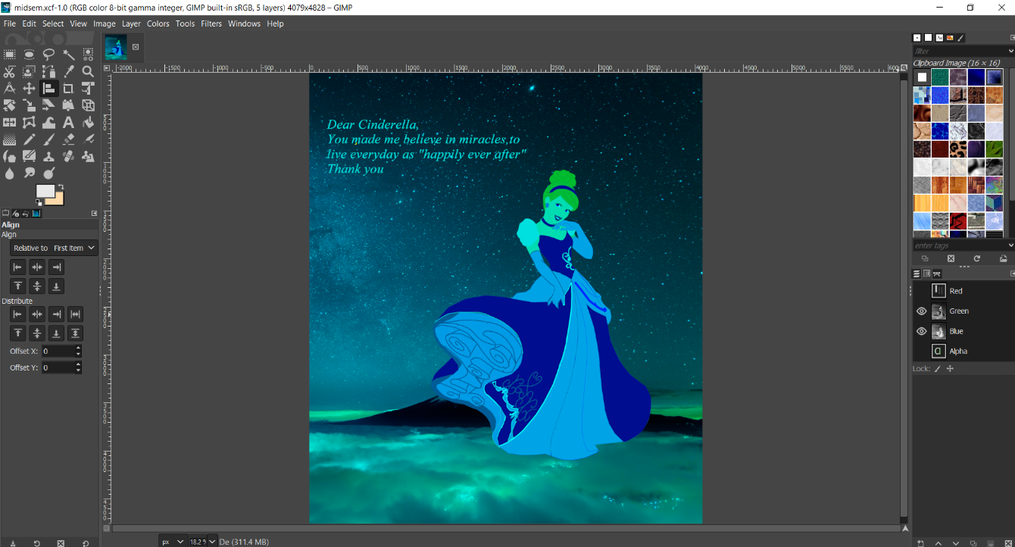

**Effect of Blue – Red**

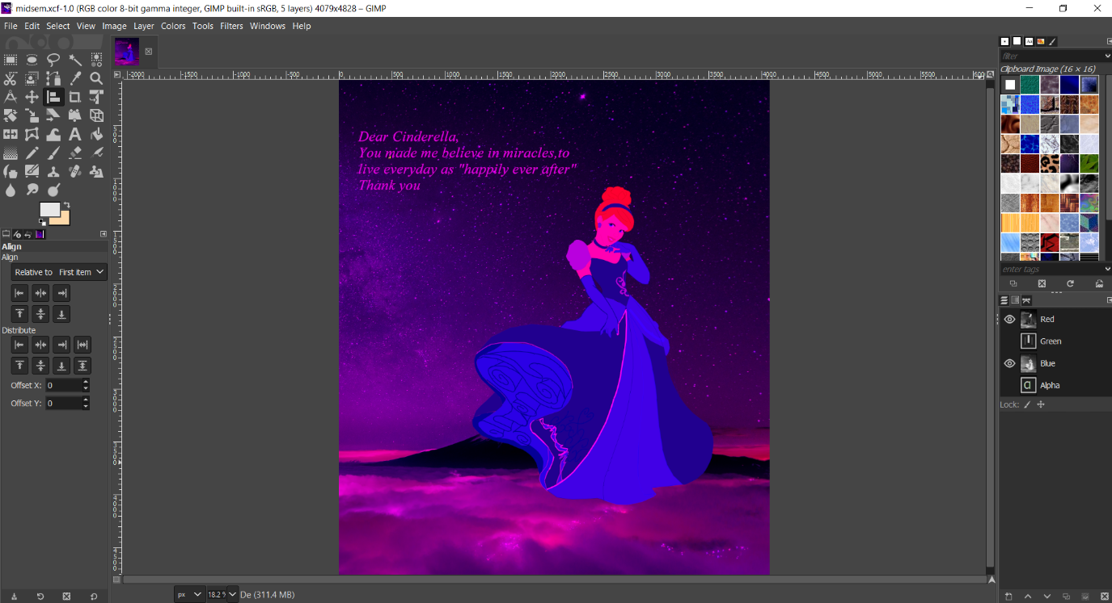

**Effect of Red – Green – Blue**

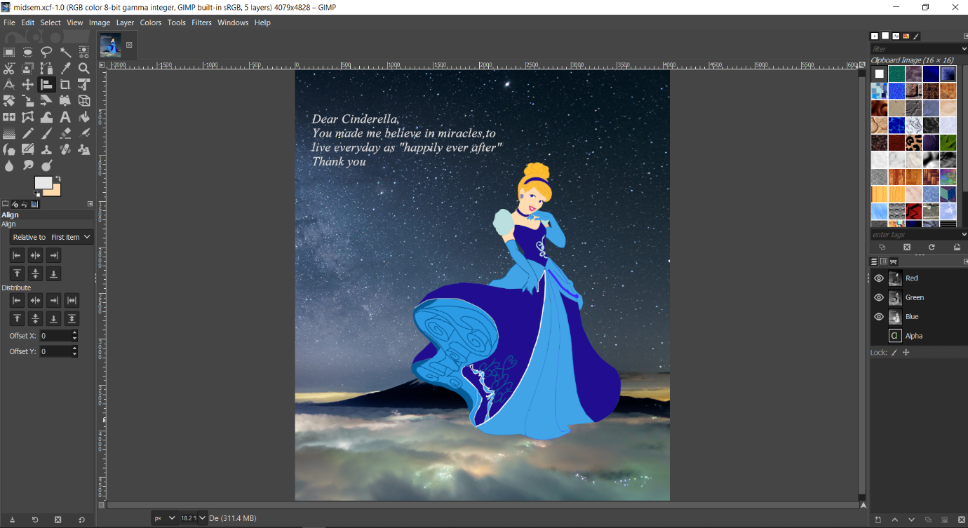

According to me, the Red-Green combination is giving the great outcome as the text as well as Cinderella is outshining and also portraying a different look. The design on Cinderella’s outfit is clearly visible in the red- green channel.

# FINAL OUTCOME :

